Getting to know your database:

Q: What is your username as reflected in this output?

APEX_PUBLIC_USER

Q: What are the system privileges granted to your username?

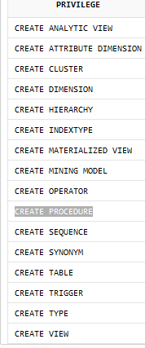

Q: How much storage are you allowed (MAX_BYTES) and from which tablespace?

10485760, 1280

Q: How much storage was allocated for this object (BYTES)?

0

Q: How much storage was allocated for this object (BYTES)?

65536

Q: Did the DROP operation have any effect on storage allocation? What is the amount of storage allocated for your user?

Yes the drop function cleared the storage that was allocated from T1. The amount of storage allocated for a user is now back to 10485760.

Q: Did the query output indicate there were objects in your schema? If so, how many objects are there and what types of objects were reported?

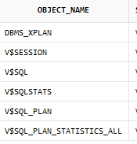

6 were in the schema and synonym was the object type

Q: Did the query output indicate there were objects accessible to you in another schema?

Yes

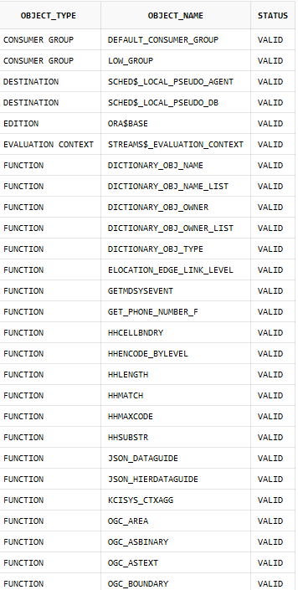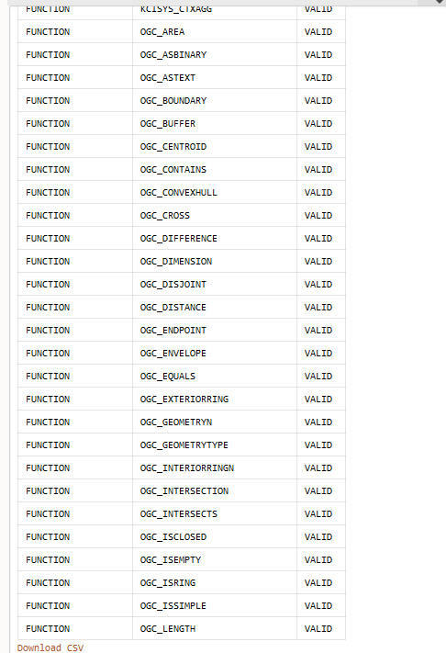

Q: How does the output of this query differ from the output produced instep 4?

The difference between this query and the one in step 4 is that there are two additional rows included, index and table.

Q: What is result of running this command?

ORA-01031: insufficient privileges

Q: How is it that your query against the DUAL table was successful? What mechanism is involved that allows you to access DUAL without a schema

**DUAL is a special table in Oracle Database that is commonly used to evaluate functions**. This table consists of one row. Because the syntax of a SELECT statement requires a column list and a table identified in the FROM clause, the DUAL table is used to satisfy a syntactic requirement.